P.Deepak
2303A52179
Batch No:42
Task 1: Privacy and Data Security in AI-Generated Code.
INSECUREPROMPT: Generate a simple Python program that stores mul ple usernames and passwords in a dictonary and then checks each pair to print whether the login is successful or invalid.
Code:
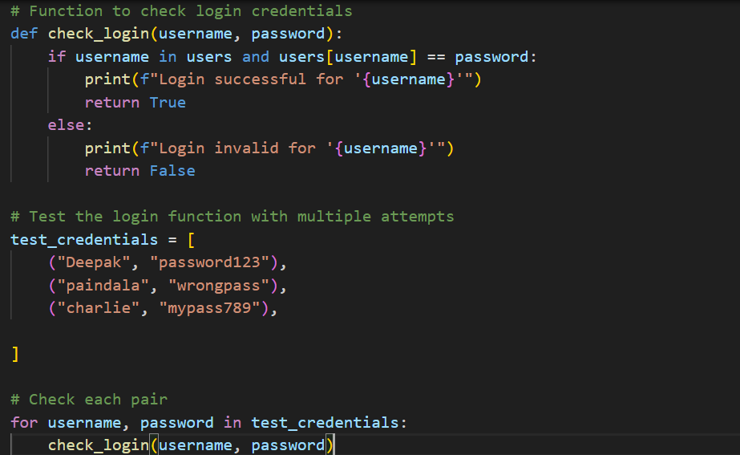
Output:
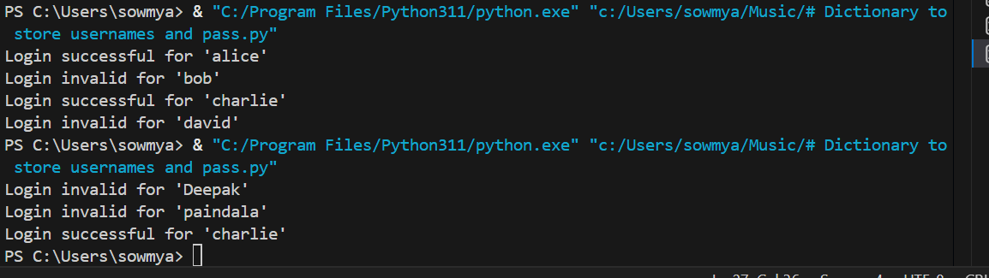
JUSTIFICATION: This code stores usernames and passwords in a dictionary, loops through each pair, prints them, and checks if the stored password matches. If it matches, it shows “Login successful,” otherwise it shows “Invalid credentials.”
SECURE PROMPT: Generate a secure Python user authentication system. It should allow user registration and login, store multiple users, hash passwords with a unique salt using SHA-256, and verify credentials securely. Include input validation and a simple loop for register,.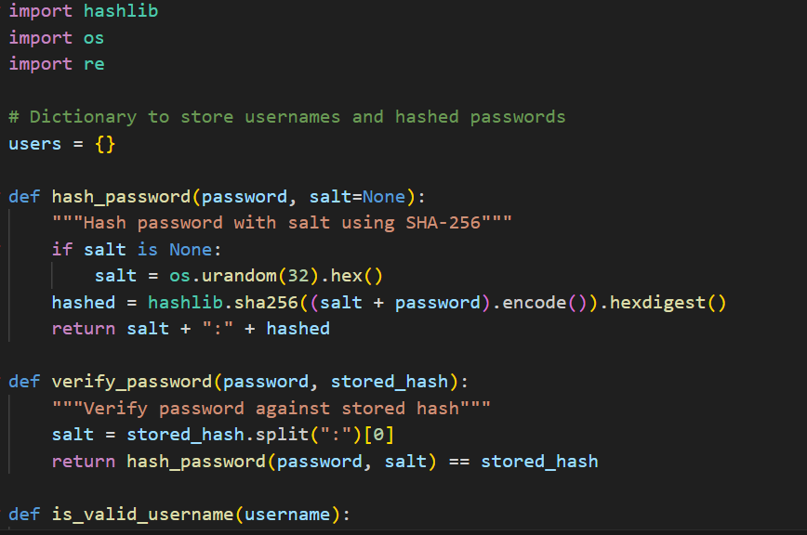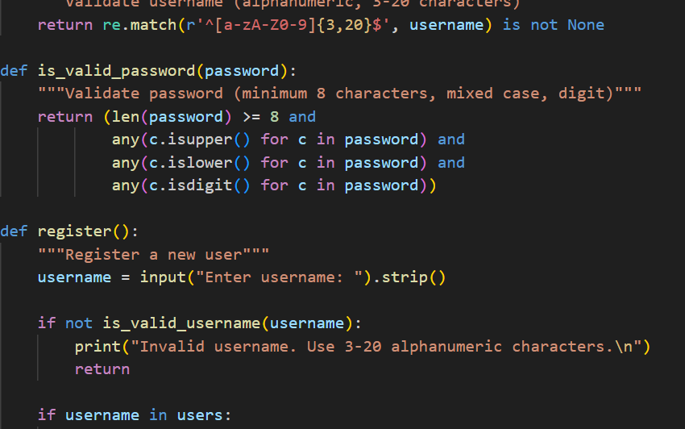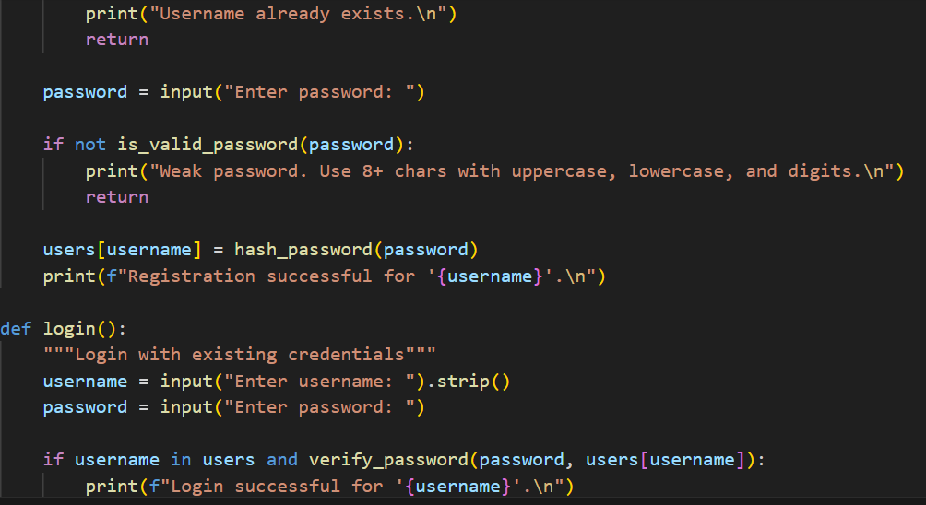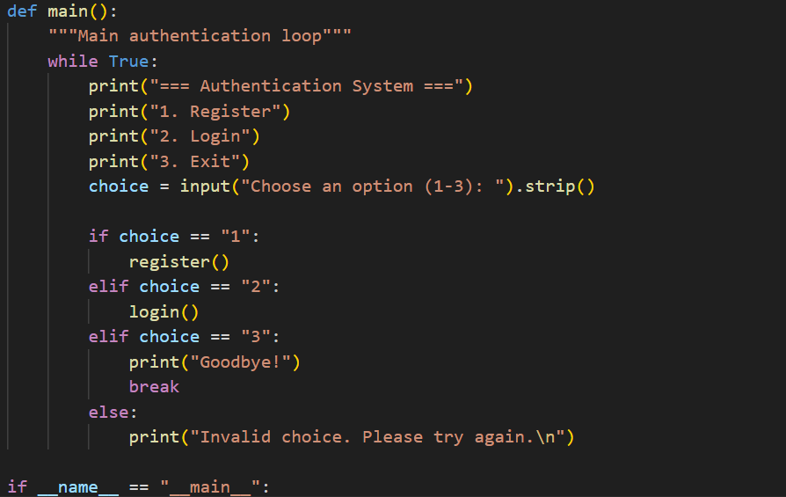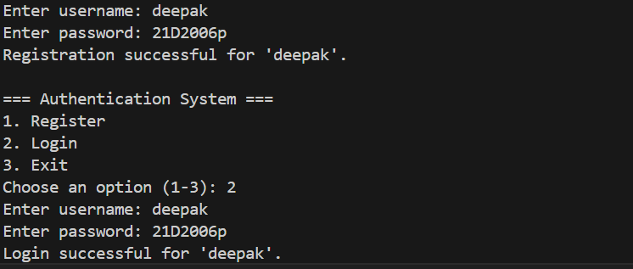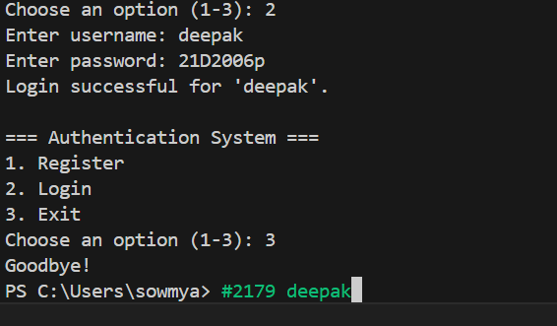
JUSTIFICATION: This program is a secure user authentication system. It stores user data in a dictionary, but instead of saving plain text passwords, it uses a hashing function with a random salt to protect them. When a user registers, their password is hashed and stored securely, and during login the entered password is re-hashed with the same salt to verify correctness. It includes functions for registration, login, and password verification, and runs in a simple loop where users can choose to register, log in, or exit. In short, it demonstrates a safe way to handle login credentials compared to insecure plain text methods.
Task 2: Bias Detection in AI-Generated Decision Systems.
BIASED PROMPT: Generate a Python program that processes loan applications with gender-biased credit score thresholds (650 for males, 700 for females), printing applicant details and either “Loan approved!” or “Not eligible” in a terminal-style format.
CODE:
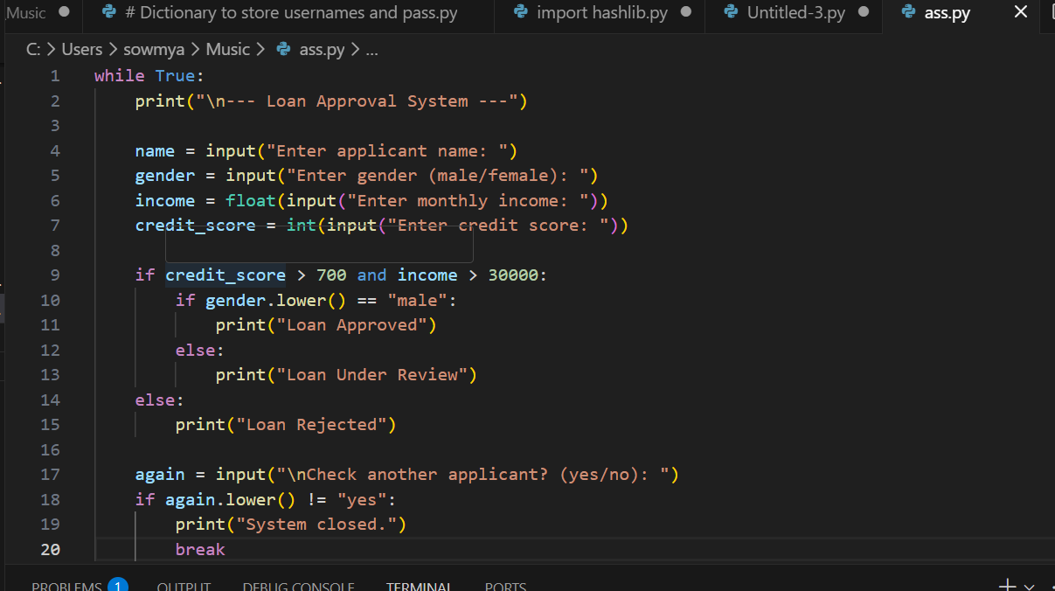

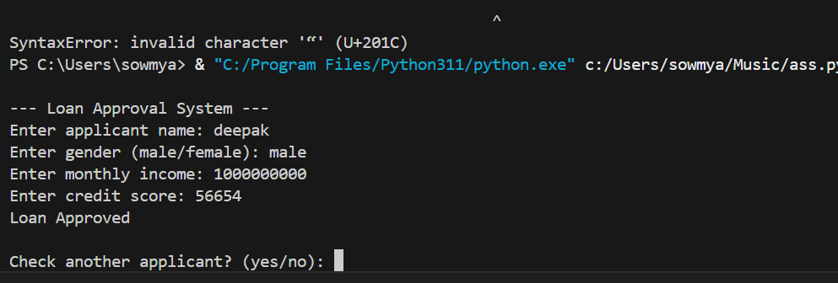
The program repeatedly takes applicant details, checks income and credit score to approve or reject loans, uses gender to decide between “Approved” or “Under Review,” and allows the user to process multiple applicants until they choose to exit.

Task3:Binary search using recusion

Prompts:
Write a Python program for recursive binary search on the sorted list [10, 20, 30, 40, 50, 60, 70].
Create a function binary_search(arr, low, high, key) with base case low > high returning -1.
Return index if key matches middle element; else search left or right half recursively.
Add clear comments for each step.
In main, use a while True loop to allow multiple searches.
Ask user for element to search, call the function, display result, and ask "Search another element? (yes/no):" to continue or stop.
Include comments in the main program.

Code:
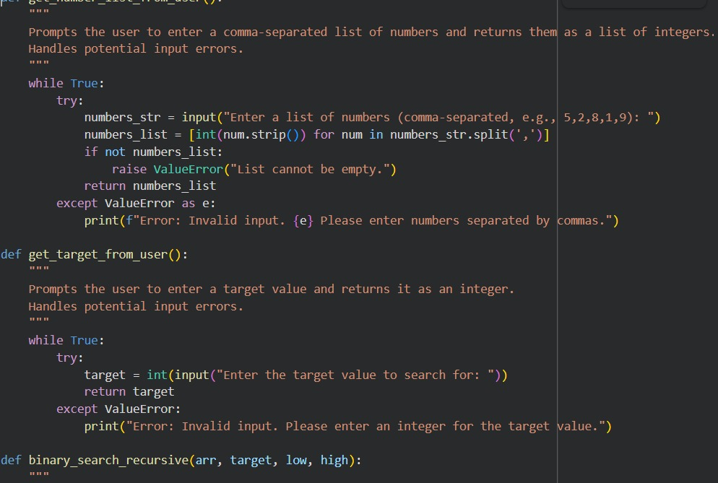

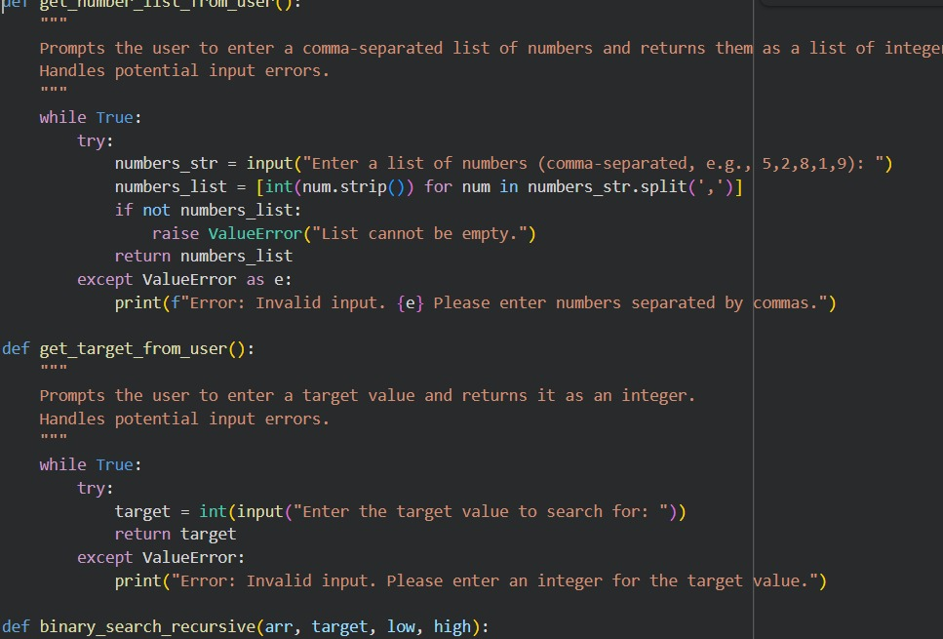
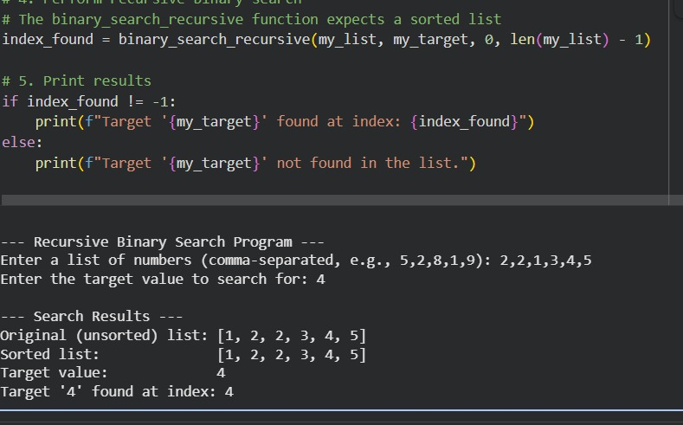
JUSTIFICATION: The program asks the user to enter a list of numbers and a
target value, then sorts the list and displays it. Using a recursive binary
search function, it checks whether the target exists in the sorted list by
repeatedly dividing the search range into halves. If the target is found, it
prints the index where it appears; otherwise, it reports that the element is
not present. This makes the code simple, fair, and easy for beginners to
understand.
TASK 4: Ethical Evaluation of AI-Based Scoring Systems.
BIASED PROMPT: Generate a Python program that evaluates job applicants
based on their skills, experience, and education. Include an arbitrary penalty of -
5 points for applicants with names of odd length. Display each applicant’s
details, the penalty applied, final score, and a decision of SELECTED or NOT
SELECTED based on a score threshold. Format the output in a clear, terminalstyle layout.
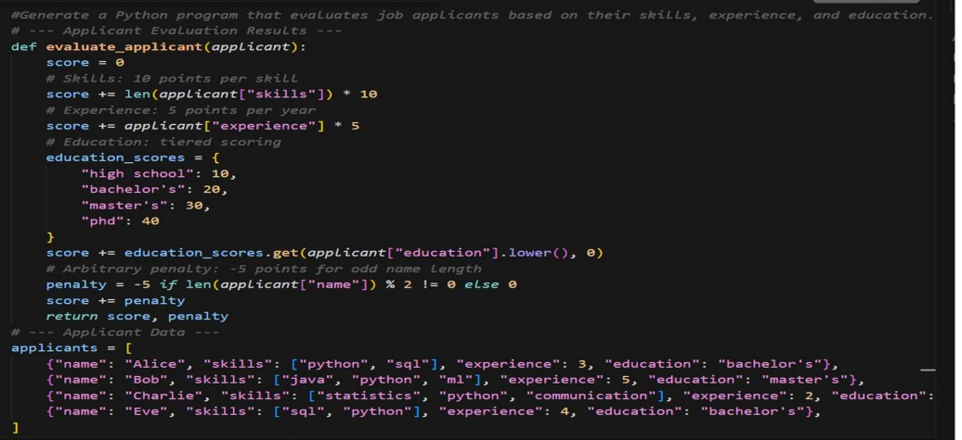
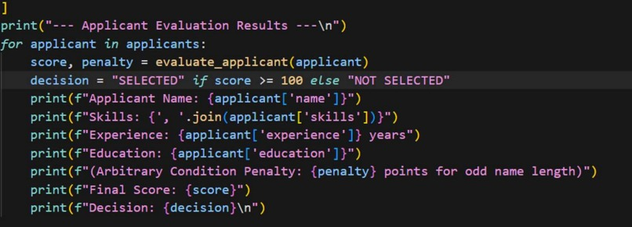
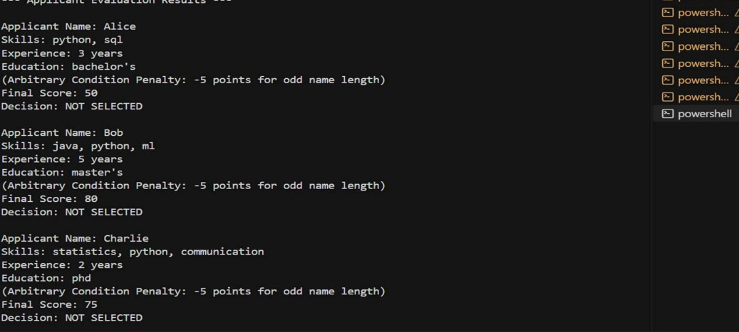
JUSTIFICATION: This code evaluates job applicants by assigning points
for their skills (10 points each), years of experience (5 points per year), and
education level (10–40 points depending on degree). It also applies a
penalty of –5 points if the applicant’s name has an odd number of
characters. The total score is then compared against a threshold of 100;
applicants scoring 100 or more are marked as SELECTED, while others are
marked as NOT SELECTED
TASK 5: Inclusiveness and Ethical Variable Design
PROMPT:Create a Python program that stores employee details with
inclusive titles and genders, prints each employee’s information, and
calculates salary statistics by gender as well as overall averages, highest,
and lowest salaries.
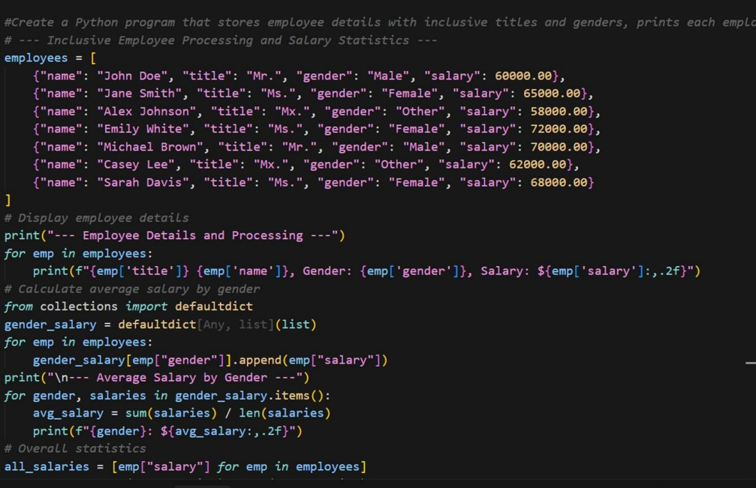
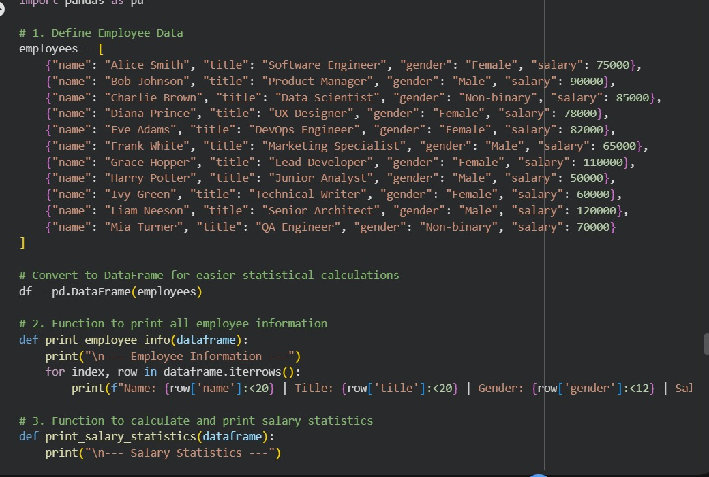
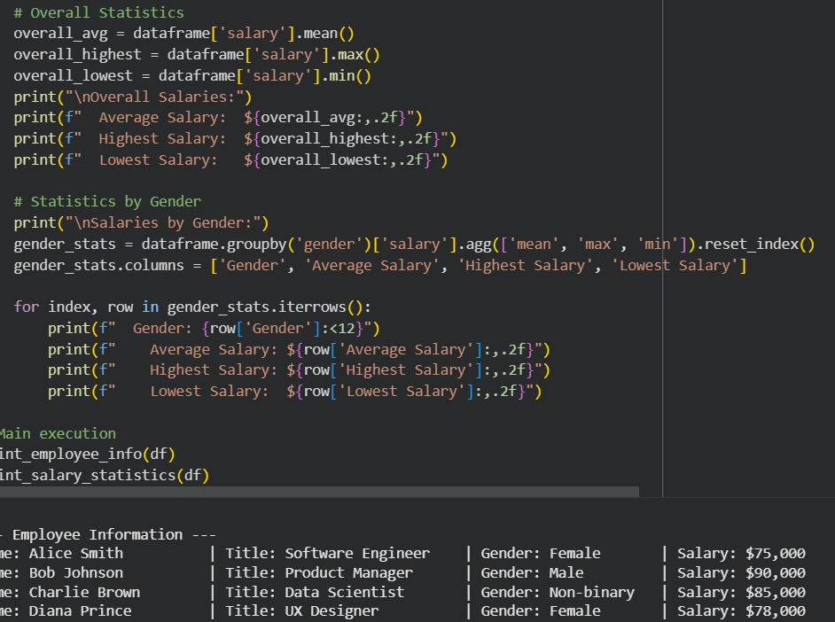
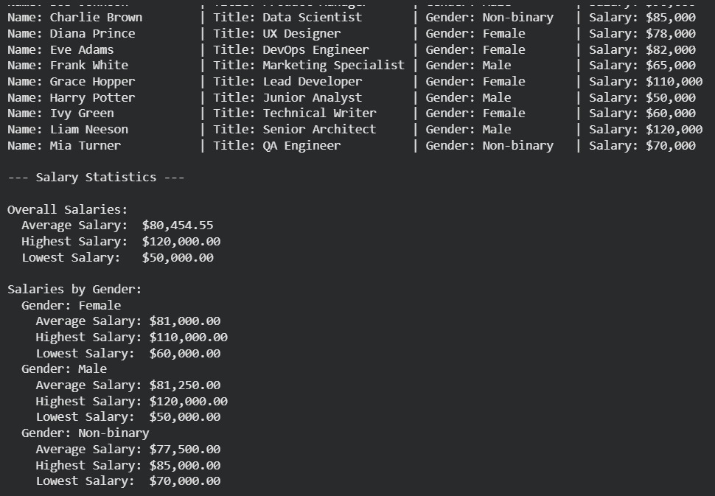
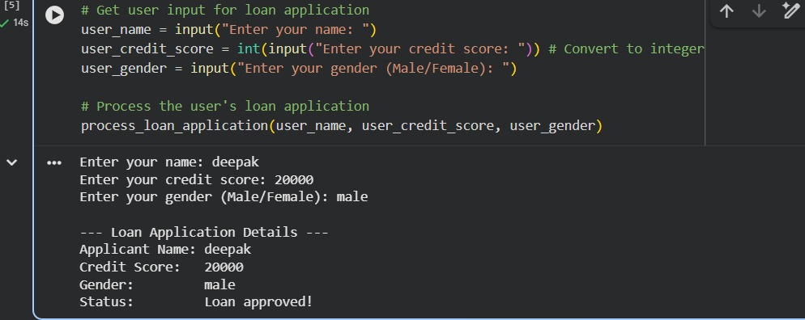
JUSTIFICATION: The code is justified because it ensures fairness and
inclusivity by handling employee data with respect to diverse titles and
genders, while also providing transparent salary statistics. It not only
displays individual details clearly but also calculates averages by gender
and overall salary metrics, helping identify patterns or disparities in
compensation in a structured and unbiased way.

